**LAB EXPERIMENT - 1**

**Objective 1: Show step by step process of installation of JDK and set path variable for it.**

STEP 1: Search on Google for “DOWNLOAD JDK”.



STEP 2: Click on the first original link of Oracle.

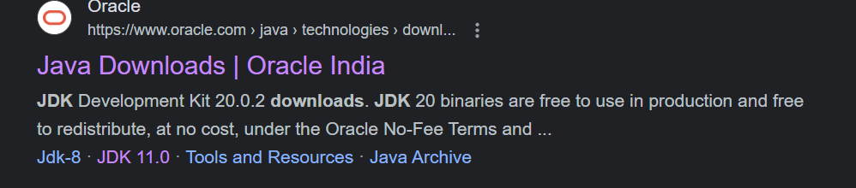

STEP 3:

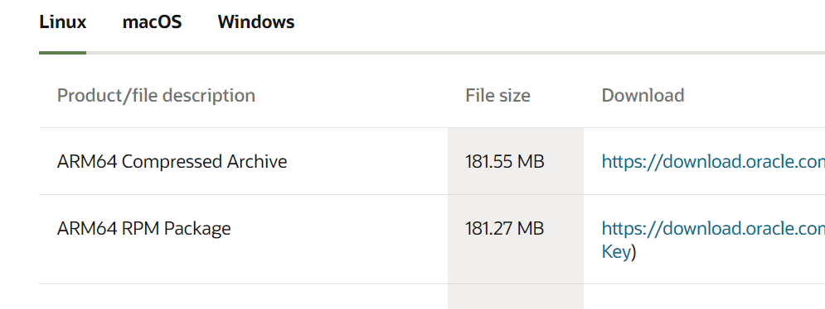

STEP 4:

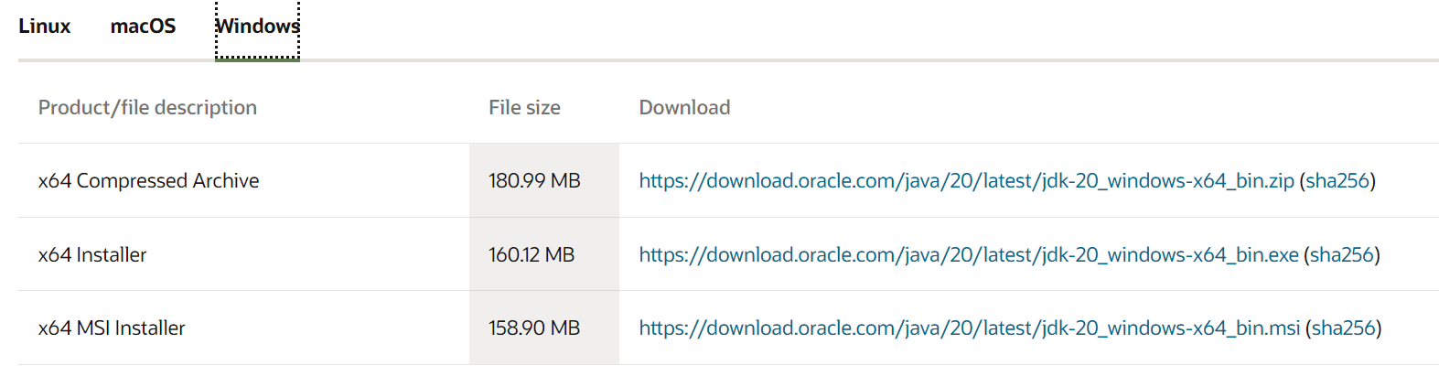

STEP 5:



STEP 6: Start Download

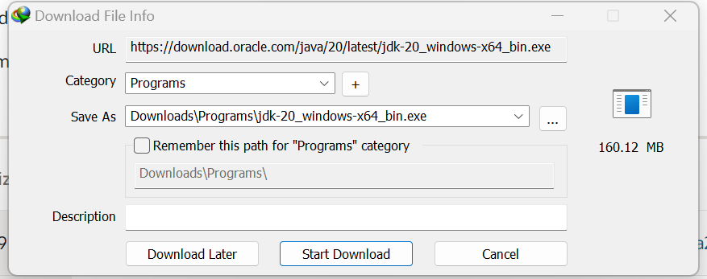

STEP 7:

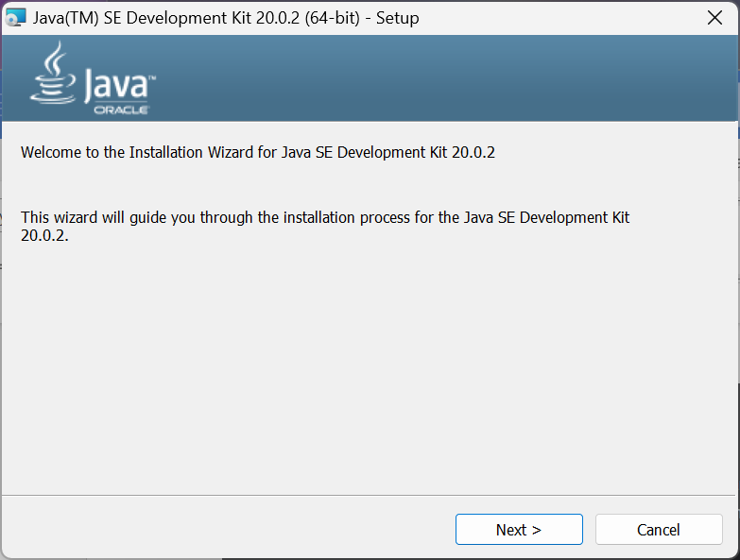

STEP 8:

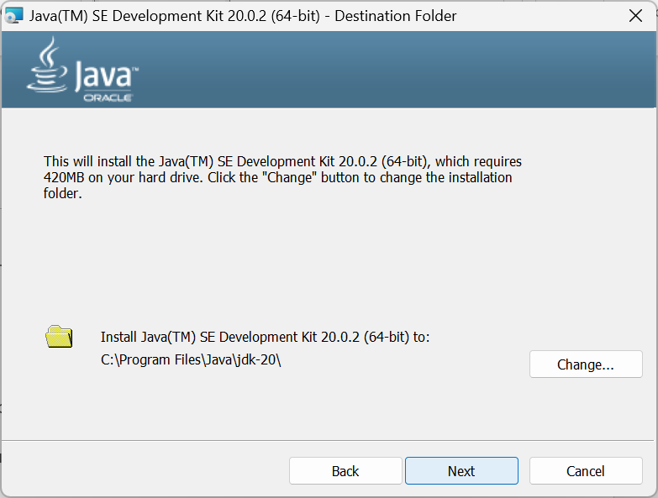

STEP 9:

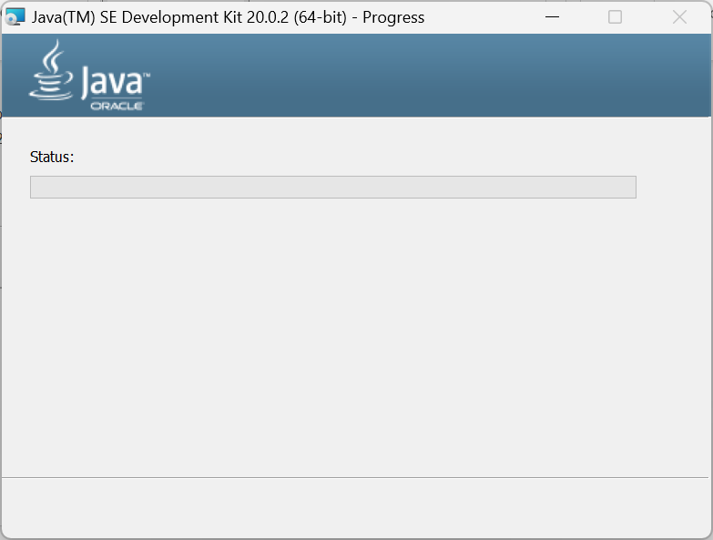

STEP 10:

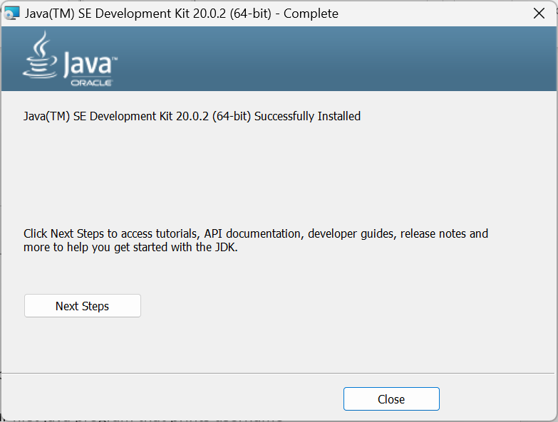

STEP 11:

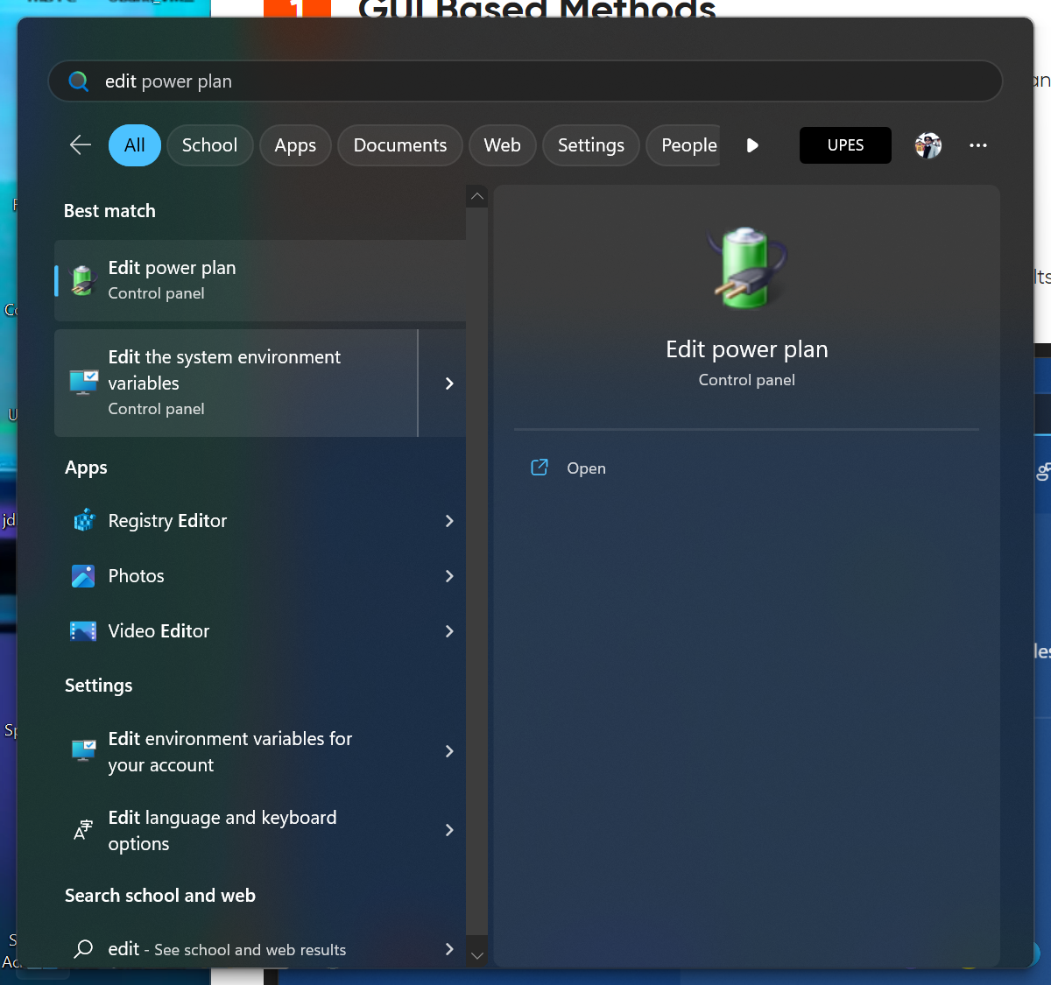

STEP 12:

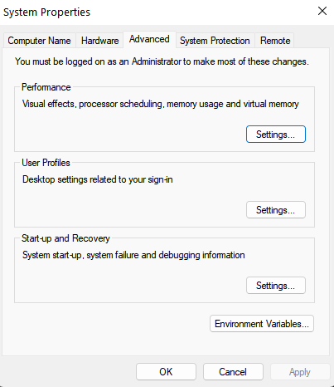

**Objective 2: Write about five popular java IDE's**

**1. Visual Studio Code**



[Visual Studio Code](https://code.visualstudio.com/) or VSCode, is a free, open-source IDE that has gained a lot of popularity in recent years. It's highly customizable, with a wide range of extensions available for various languages and frameworks. VSCode also has a built-in debugging feature and Git integration. You can customize any aspect of VS Code, from themes to key bindings to integrations and functions. Thanks to its flexibility, Visual Studio is a great tool for both students and professionals.

Languages supported: PHP, HTML, CSS, SCSS, Less, JavaScript, JSON, TypeScript, Markdown, PowerShell, C++, Java, Python, Go, T-SQL, C#, .NET Core, and more.

**2. NetBeans**



[Netbeans](https://netbeans.org/) is a free and open-source IDE. It was initially developed by Sun Microsystems and is now maintained by the Apache Software Foundation. NetBeans is known for its comprehensive feature set and ease of use, making it a popular choice among Java developers. One of the key features of NetBeans is its Java-centric approach, providing a wide range of tools and features specifically designed for Java development.

It includes a code editor with syntax highlighting, code completion, and error checking, as well as a built-in debugger and profiler. It also supports a wide range of Java frameworks and technologies, such as JavaFX, Java EE, and Spring. Ideal for editing existing projects or starting from scratch, NetBeans boasts a simple drag-and-drop interface that comes with a myriad of convenient project templates. It is primarily used to develop Java applications, but you can download bundles that support other languages.

Languages supported: C, C++, C++11, Fortan, HTML 5, Java, PHP and more

**3. PyCharm**

[PyCharm](https://www.jetbrains.com/pycharm/) is developed by the folks over at Jet Brains and provides users a free Community Edition, 30 day free trial for the Professional edition, and the Professional (paid) edition. PyCharm is known for its comprehensive feature set and ease of use, making it a popular choice among Python developers.

One of the key features of PyCharm is its support for a wide range of Python frameworks and technologies, such as Django, Flask, and Pyramid. It includes a code editor with syntax highlighting, code completion, and error checking, as well as a built-in debugger and profiler. PyCharm also has a built-in support for version control systems such as Git and SVN, making it easy to manage and collaborate on code.

PyCharm also includes support for web development and JavaScript, HTML, and CSS. It also provides a feature called the 'Scientific mode' that is designed to be used with scientific libraries such as NumPy, SciPy and Matplotlib.

Languages supported: AngularJS, Coffee Script, CSS, Cython, HTML, JavaScript, Node.js, Python, TypeScript and template languages

**4. IntelliJ IDEA**



[IntelliJ IDEA](https://www.jetbrains.com/idea/) is a powerful and feature-rich IDE developed by JetBrains. It is available in both a Community (free) and Ultimate (paid) edition and is widely used by Java, Kotlin, Scala, and other JVM language developers. IntelliJ IDEA is known for its intelligent code completion, error checking, and powerful refactoring capabilities, making it a popular choice among developers.

IntelliJ IDEA provides a wide range of tools and features specifically designed for Java development, including support for a wide range of Java frameworks and technologies such as Spring, Hibernate, and Struts. It includes a code editor with syntax highlighting, code completion, and error checking, as well as a built-in debugger and profiler. IntelliJ IDEA also has built-in support for version control systems such as Git and SVN, making it easy to manage and collaborate on code.

Languages supported: AngularJS, CoffeeScript, CS, HTML, JavaScript, Less, Node JS, PHP, Python, Ruby, Sass, TypeScript and more.

5. Eclipse

[Eclipse](https://eclipse.org/) is a free and flexible open source editor useful for beginners and pros alike. Originally a Java environment, Eclipse now has a wide range of capabilities thanks to a large number of plugins and extensions. In addition to debugging tools and Git/CVS support, the standard edition of Eclipse comes with Java and Plugin Development Tooling. If that's not enough for you, there is plenty of other packages to choose from that include tools for charting, modeling, reporting, testing and building GUIs. The Eclipse Marketplace Client gives users access to a treasure trove of plugins and information supplied by an expanding community of developers.

Languages supported: C, C++, Java, Perl, PHP, Python, Ruby, and more

**Objective 3: Write and execute our first java program that prints username**

STEP 1:

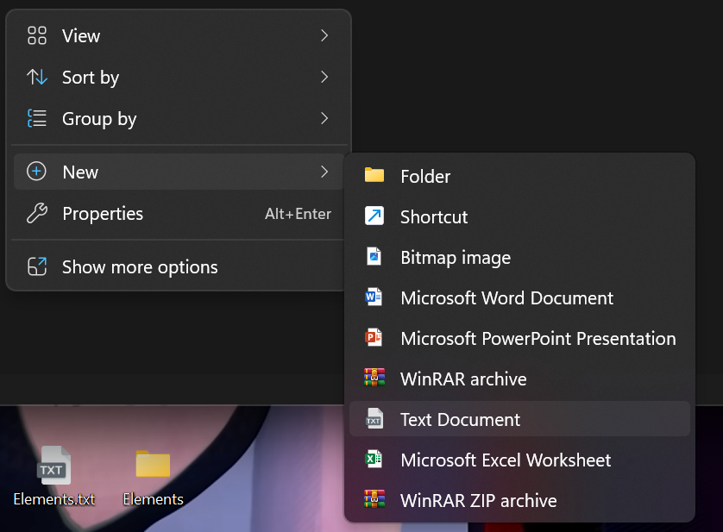

STEP 2:

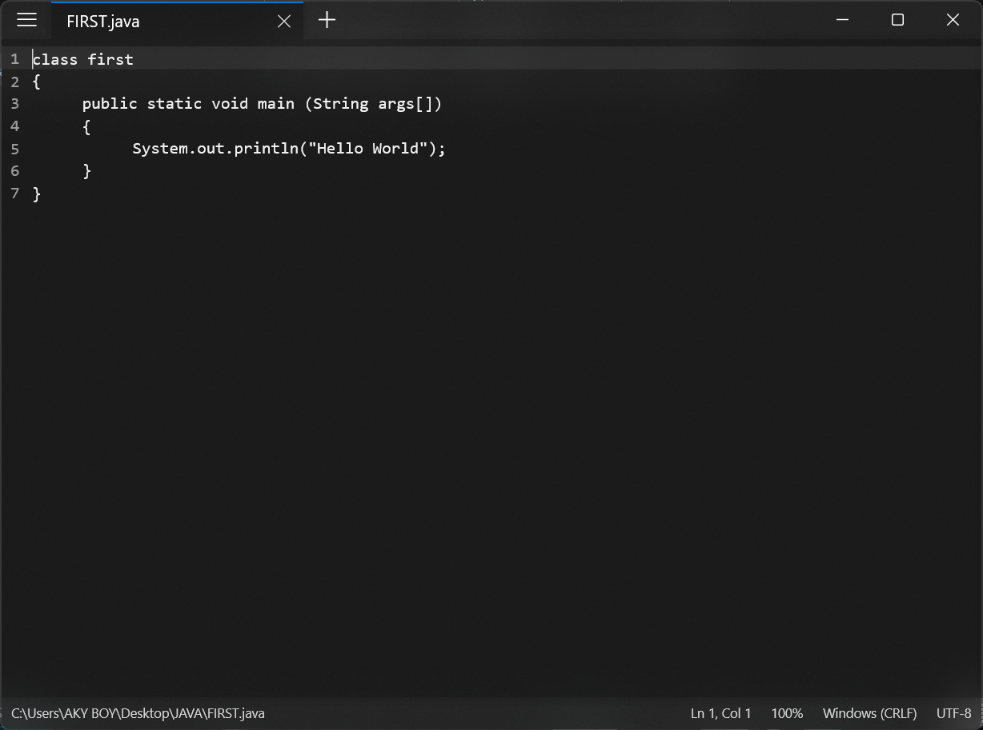

STEP 3:

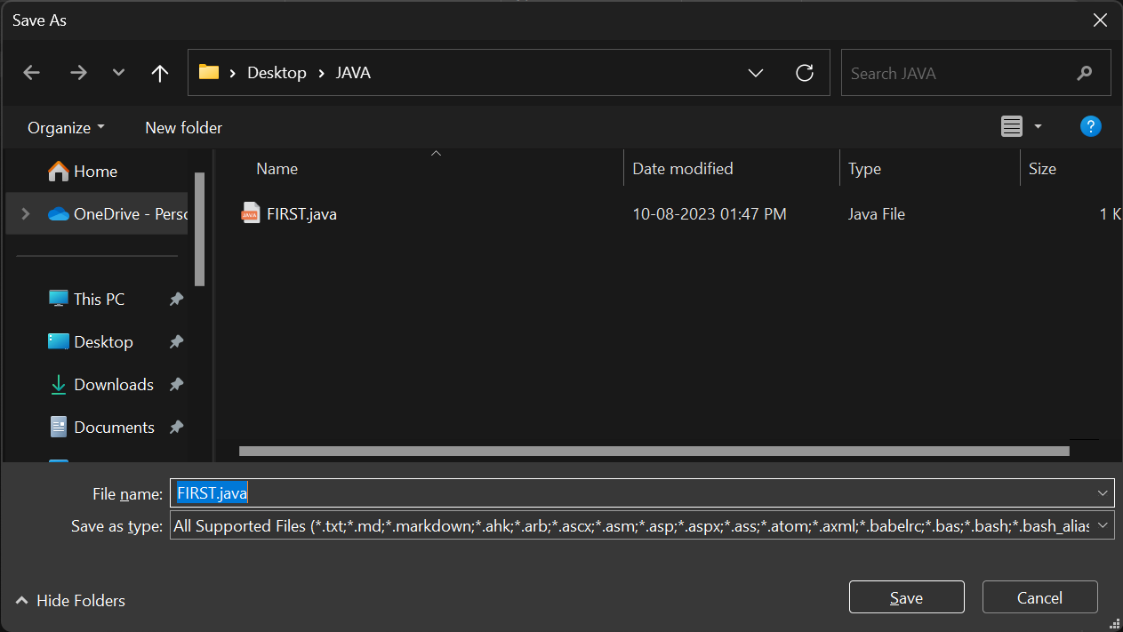

STEP 4:

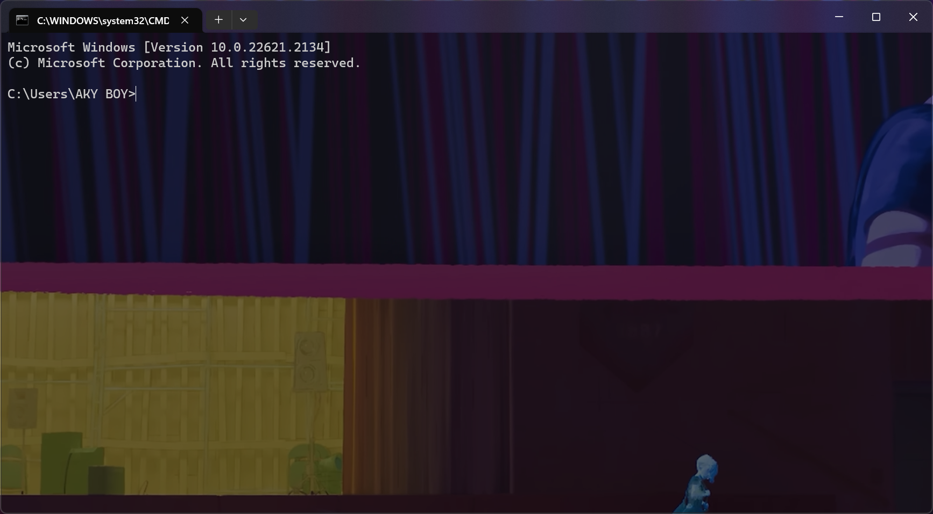

STEP 5:



STEP 6:



STEP 7:

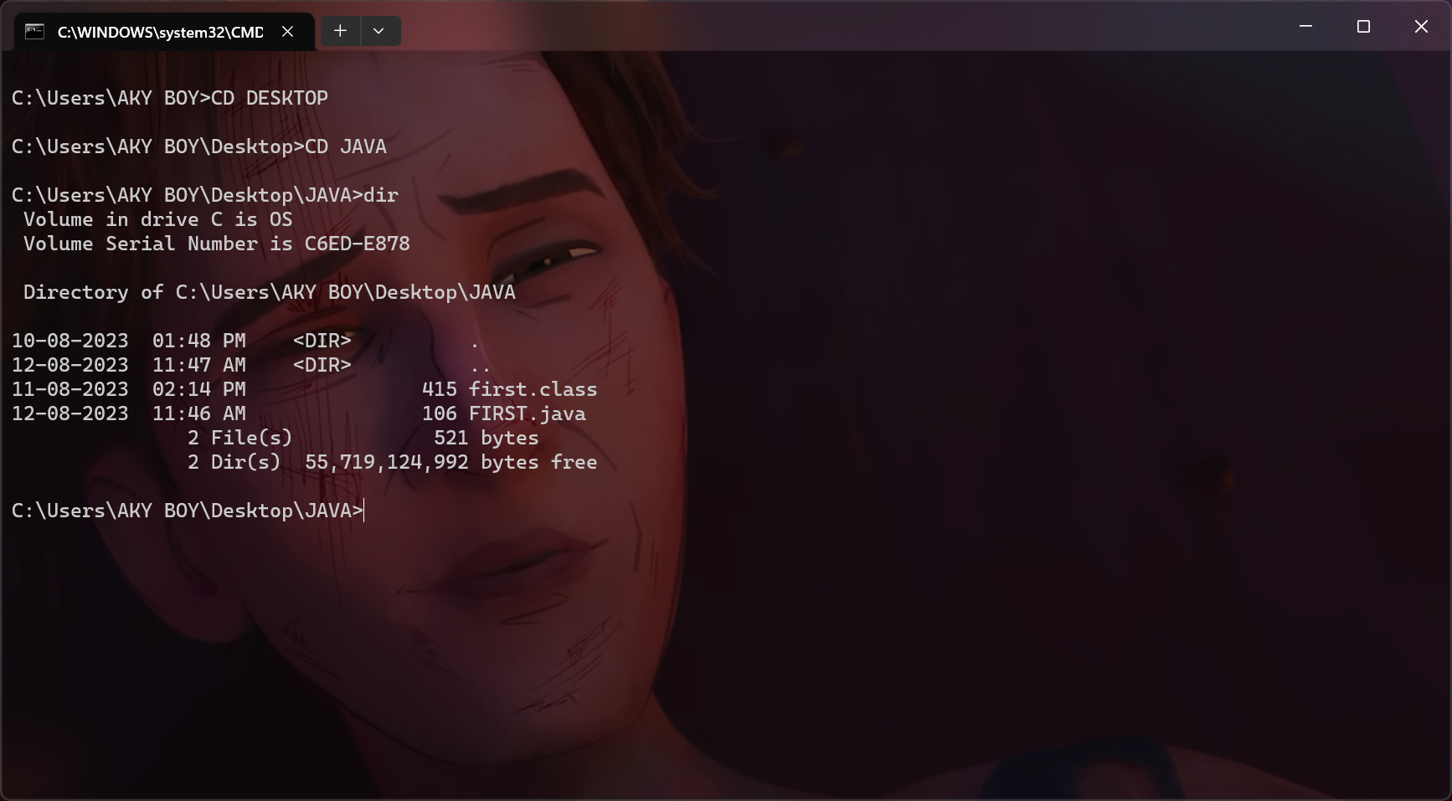

STEP 8:

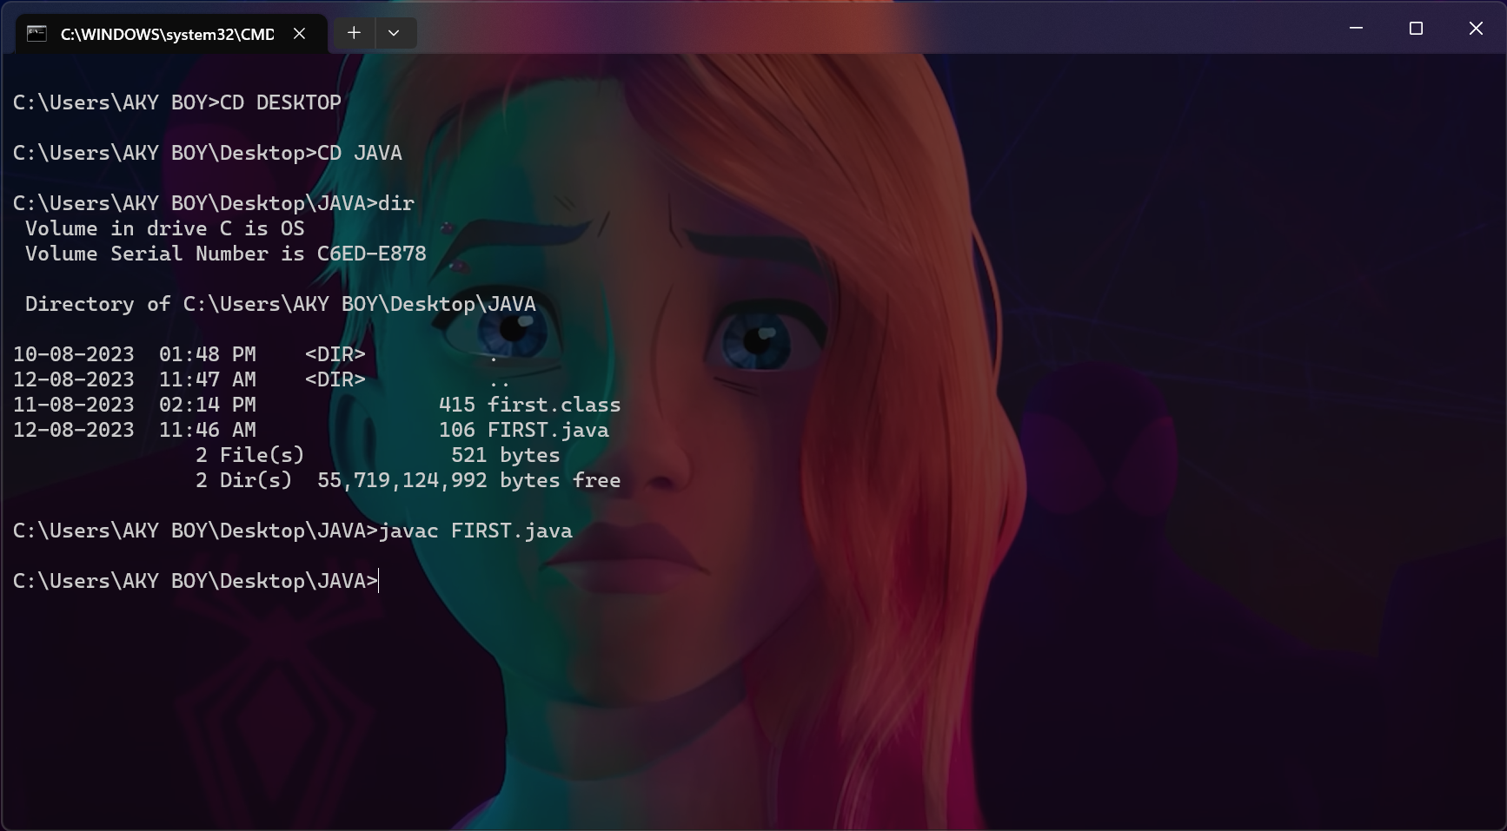

STEP 9:

